7).Create a simple cloud software application for Students Attendance System using any Cloud Service Provider to demonstrate SaaS include the necessary fields such as name of the students, course, present , Absent, course attendance, OD request, grade, attendance percentage, etc.

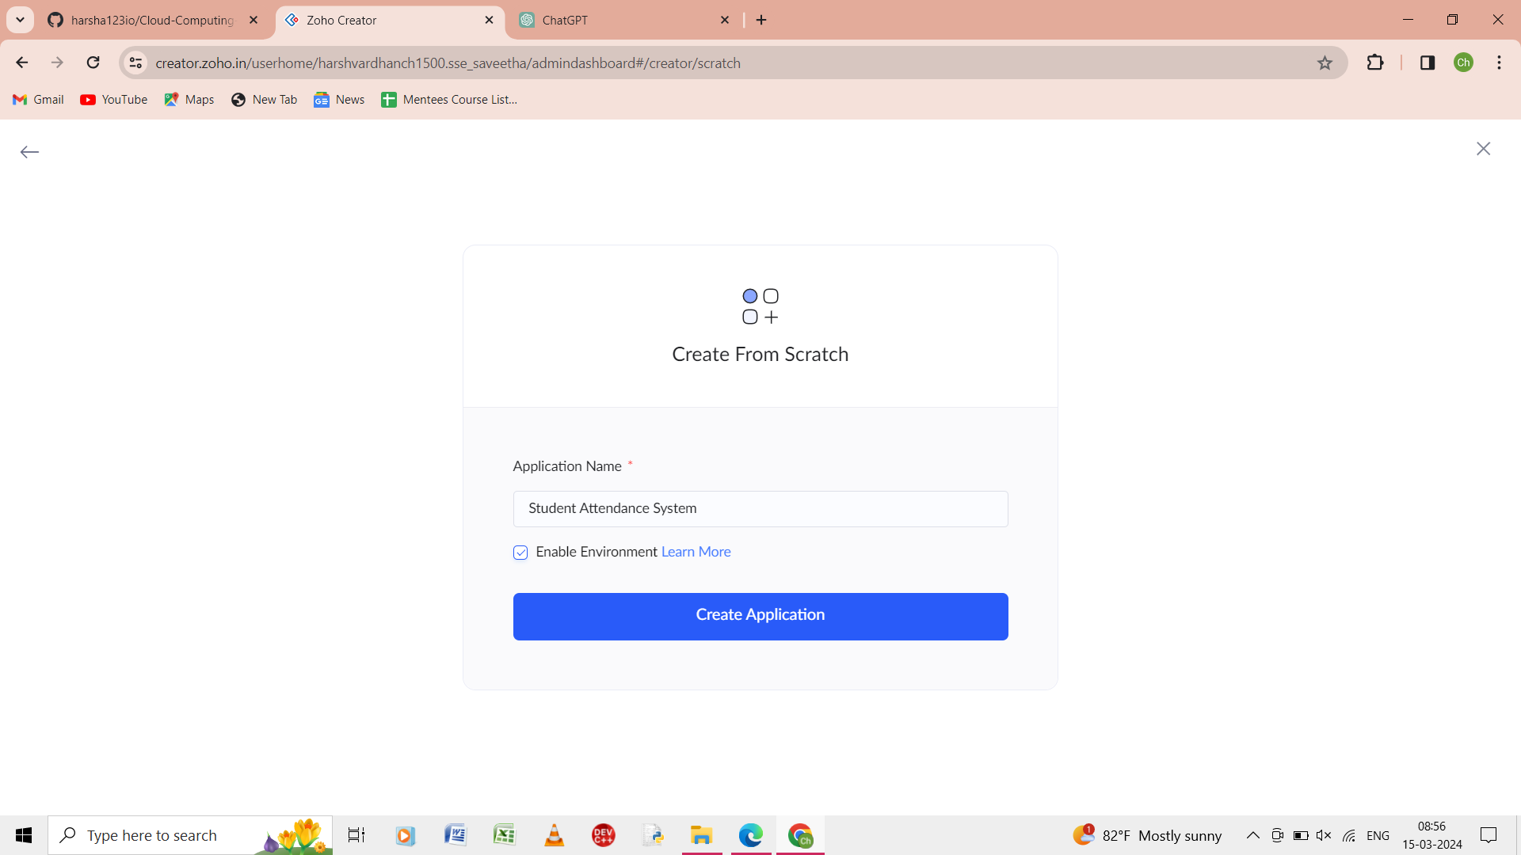

Step 1: from the scratch give the name of the application as student attendance system.

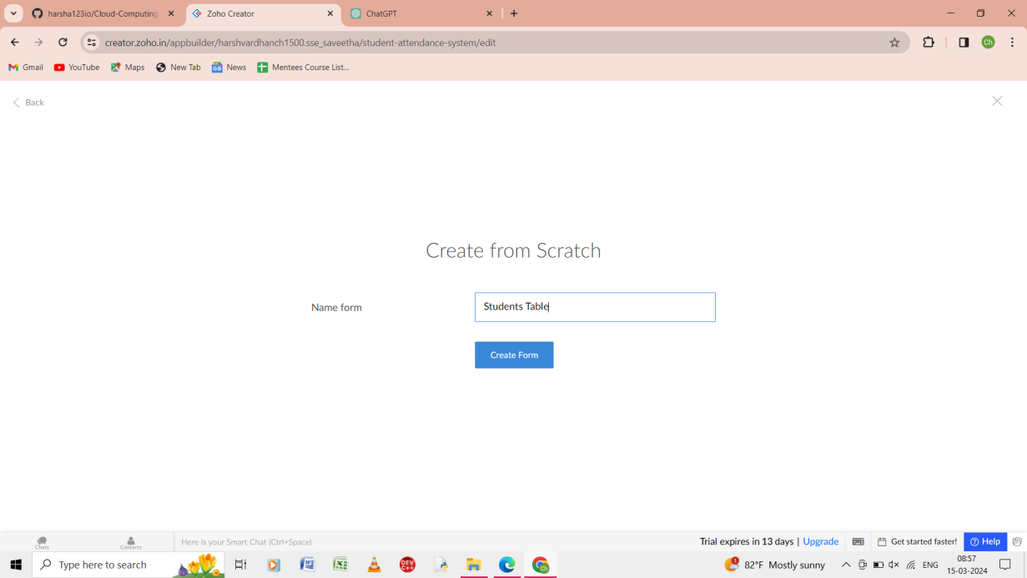

Step 2: from the scratch give the name of the form as student tables.

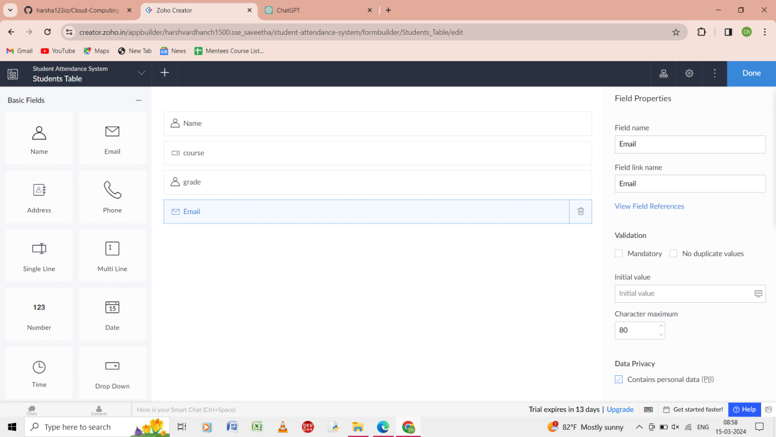

Step 3:In the form give the input as name, course, grade, email etc.

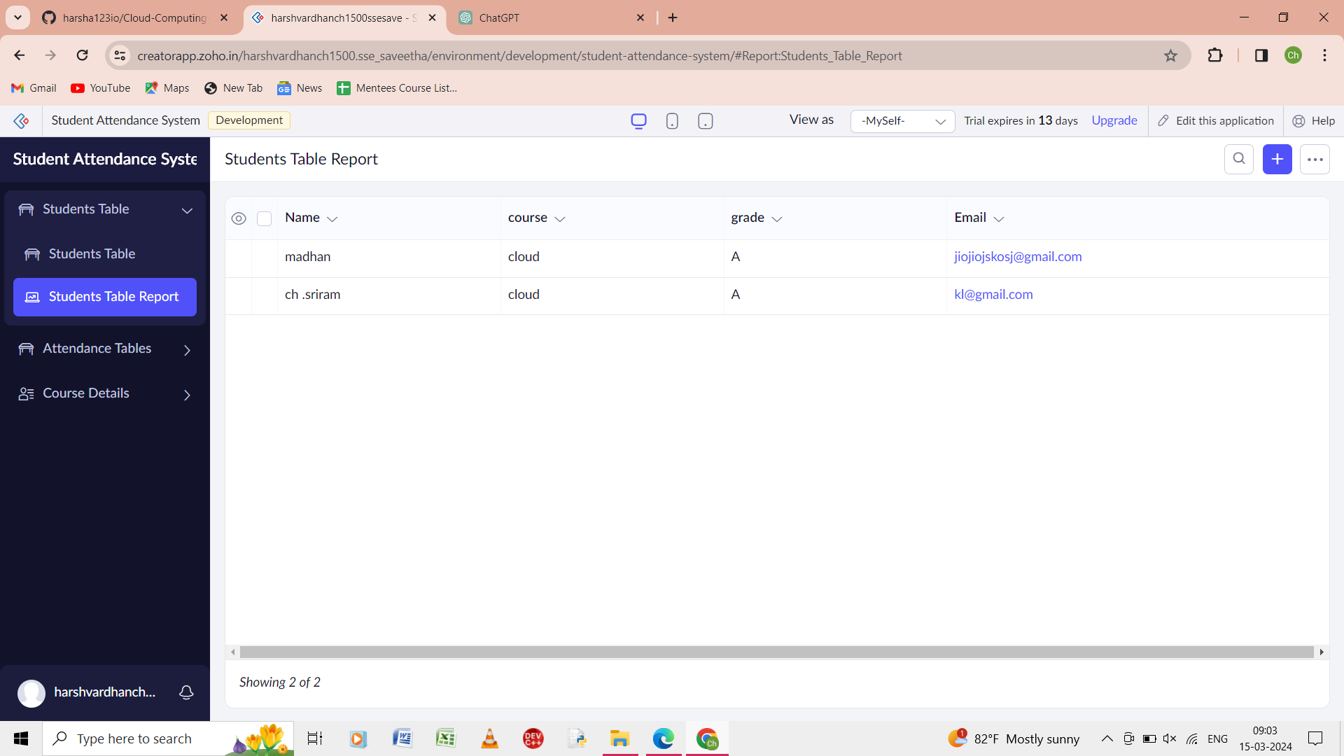

Step 4: It shows the form of the all the student table report.

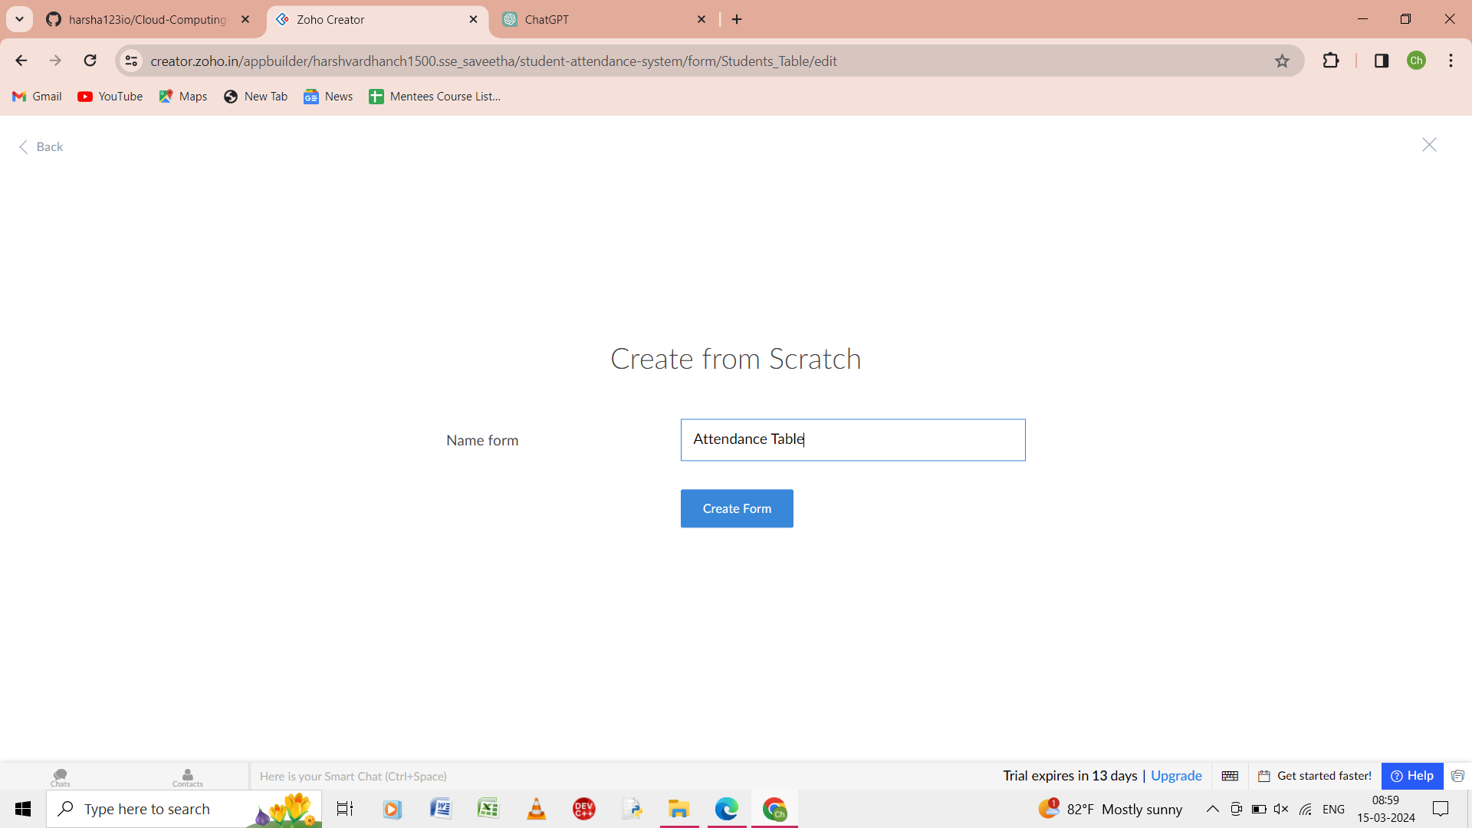

Step 5: from the scratch give the name of the form as attendance table.

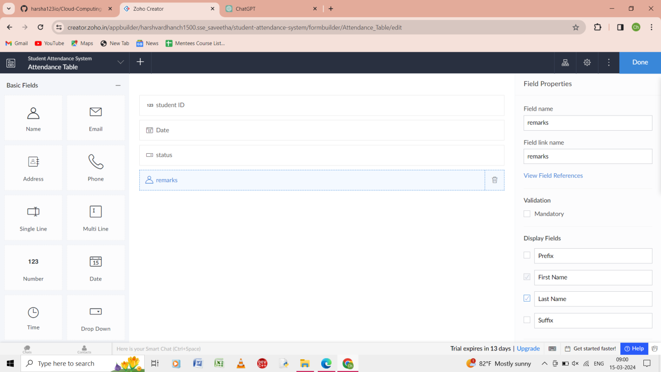

Step 6: In the form of the attendance table enter the input as student ID, date, status ,and remarks.

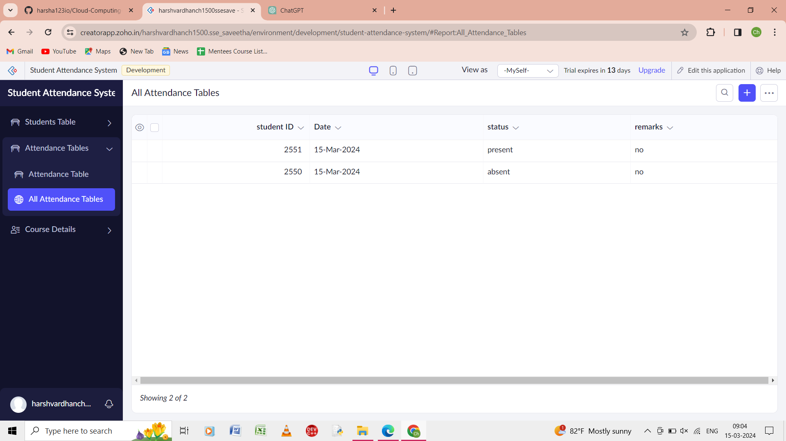

Step 7: the report of the all the attendance table of the form.

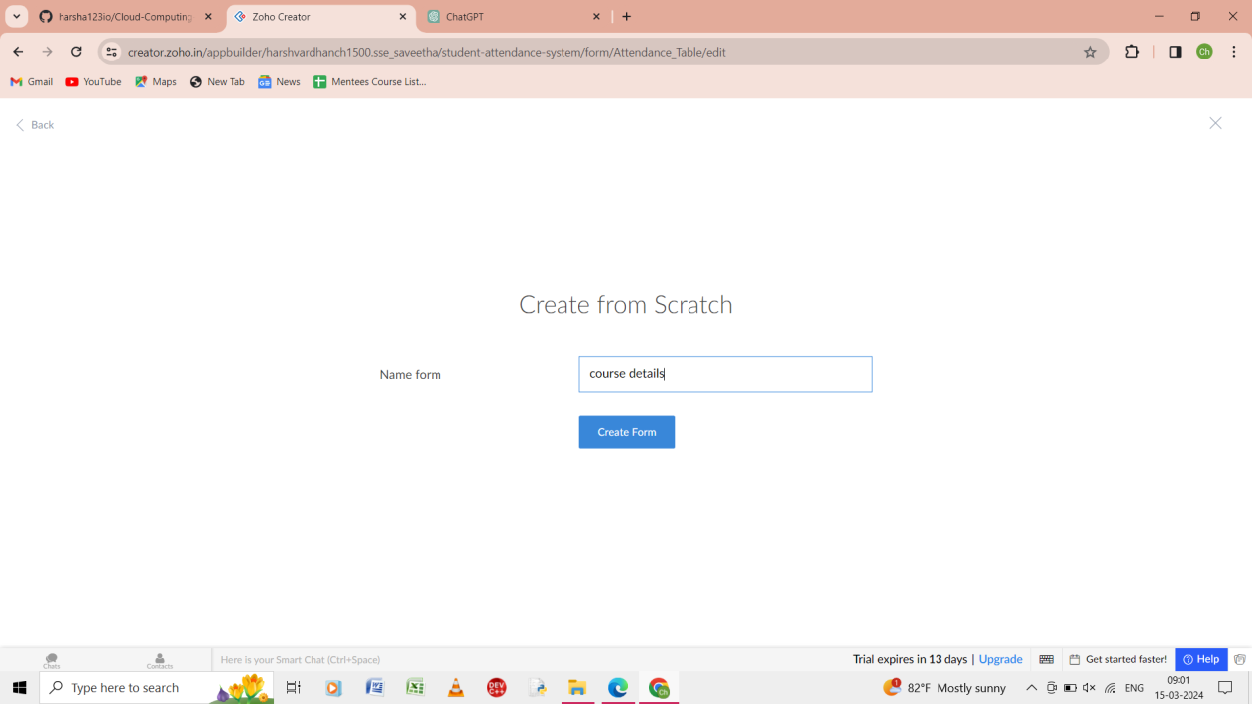

Step 8: from the scratch give the name of the form as course details.

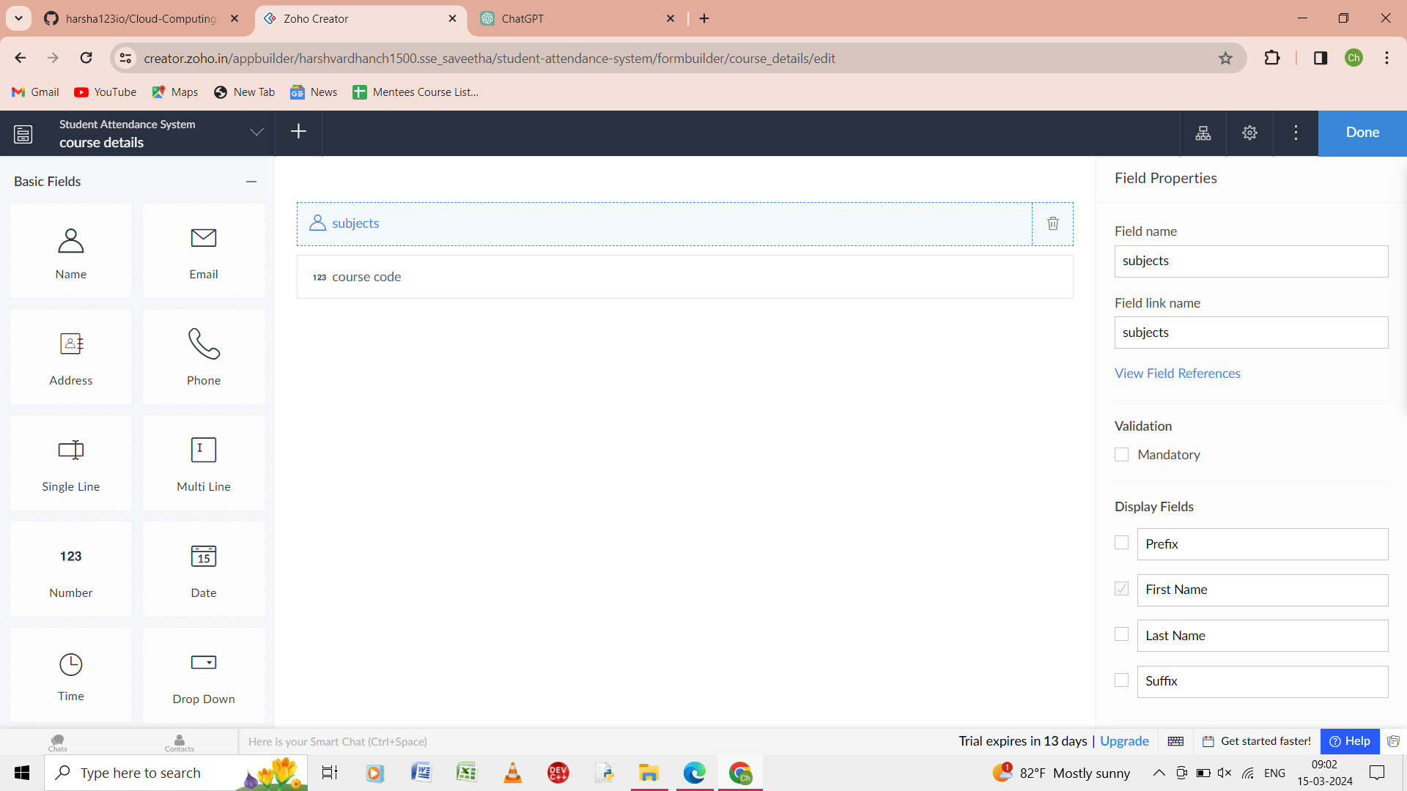

Step 9: In the form of the couse details enter the input as subjects and course code.

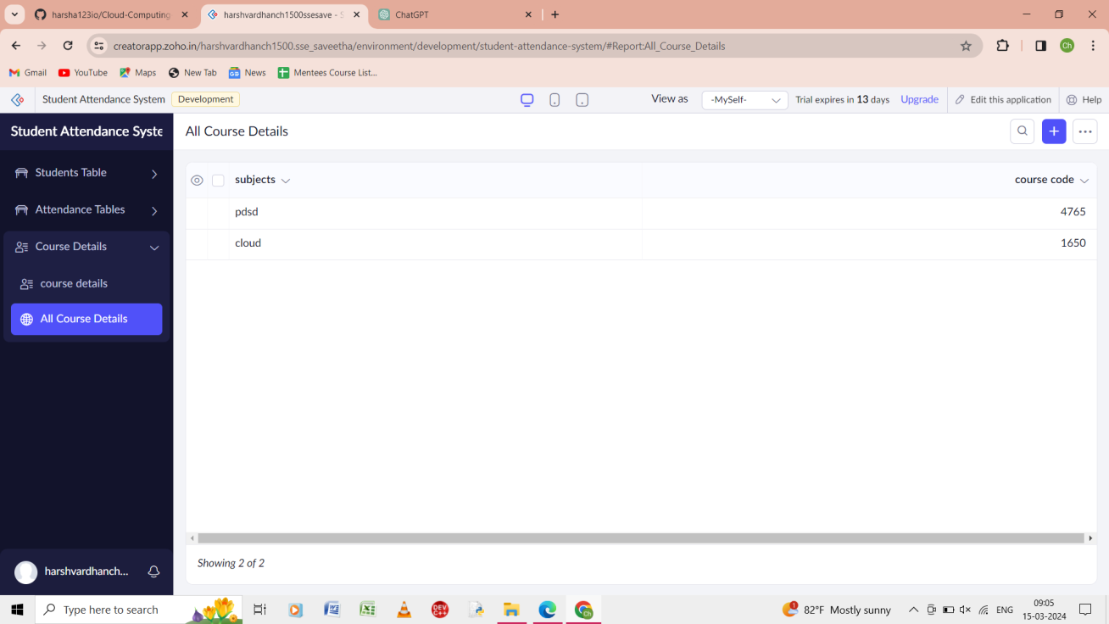

Step 10: the report of the form of all the course details is shown.